**Project Management**

**Quiz**

Question:

At Countywide Software, you are trying to convince your boss that he should consider modern project management techniques to manage a complex project. Your boss says that he doesn’t need anything fancy, and that he can guess the total time by the seat of his pants. To prove your point, you decide to use a very simple example of a commercial software project, with six tasks.

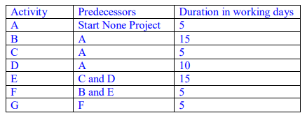

1. Create a network diagram.
2. Find out the critical path using critical path method (slack method).
3. Calculate the project probability for the following:
   1. What are the chances the project will end in 25 days?
   2. What are the chances the project will end in 20 days?

(Chart for question 3 will be given in the online session)

|  |  |  |  |  |  |  |
| --- | --- | --- | --- | --- | --- | --- |
| Activity | Predecessor | Optimistic | Most Likely | Pessimistic | Expected Time | Variance |
| A |  | 4 | 5 | 8 |  |  |
| B | A | 12 | 15 | 18 |  |  |
| C | A | 4 | 5 | 8 |  |  |
| D | A | 8 | 10 | 12 |  |  |
| E | C and D | 12 | 15 | 18 |  |  |
| F | B and E | 4 | 5 | 8 |  |  |
| G | F | 4 | 5 | 8 |  |  |